# MySQL Joints

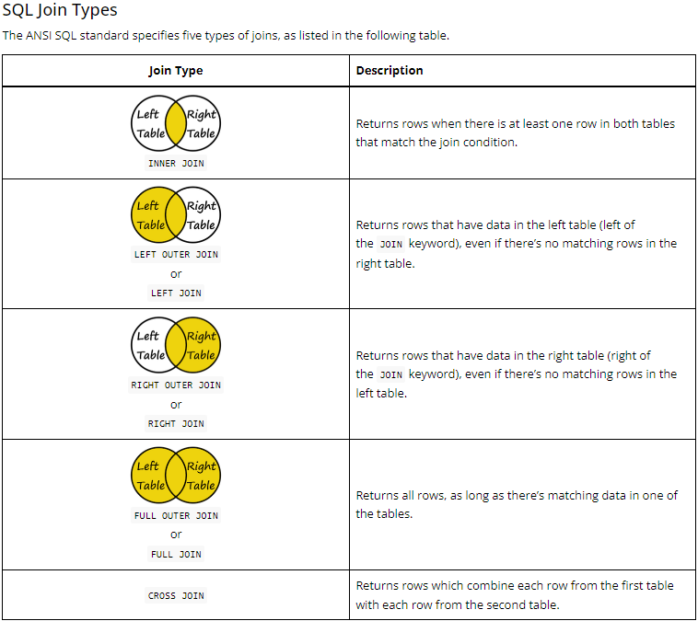

**Few More Joins:**

